**PROJECT KICKOFF**

**PROJECT NAME:** *Smart Agriculture system based on IoT*

**PROJECT MANAGER:** Pasupula Rajini

**Project Scope****:**

# Project Summary

"Smart Agriculture System based on IoT", it’s a device/app based on IoT. which provides the info regarding weather conditions like temperature, humidity, and soil moisture. Which helps user to monitor the things easily.

# Project Requirements

* IBM Cloud
* IBM Watson IoT platform
* Node-Red
* Python IDE

# Functional Requirements

* IoT Simulator
* Open weather API

# Technical Requirements

* Web application

# Software Requirements

* Node-Red
* Python IDE

**Project Schedule:**

* 18/06 -Project Details,Planning, Creation of IBM Cloud Account.

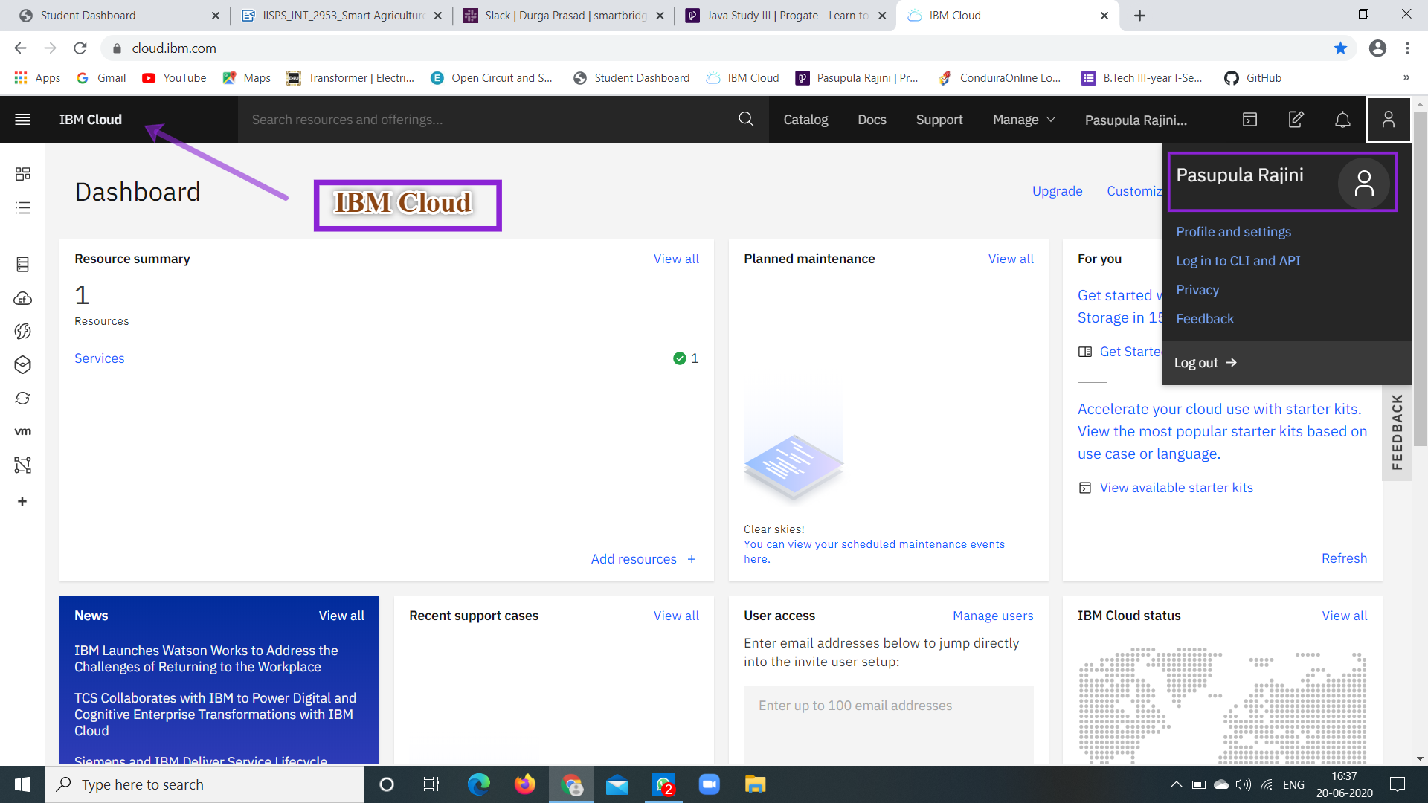

* 19/06 - Exploring IBM Watson IoT Platform(Device created,API Key & protection)

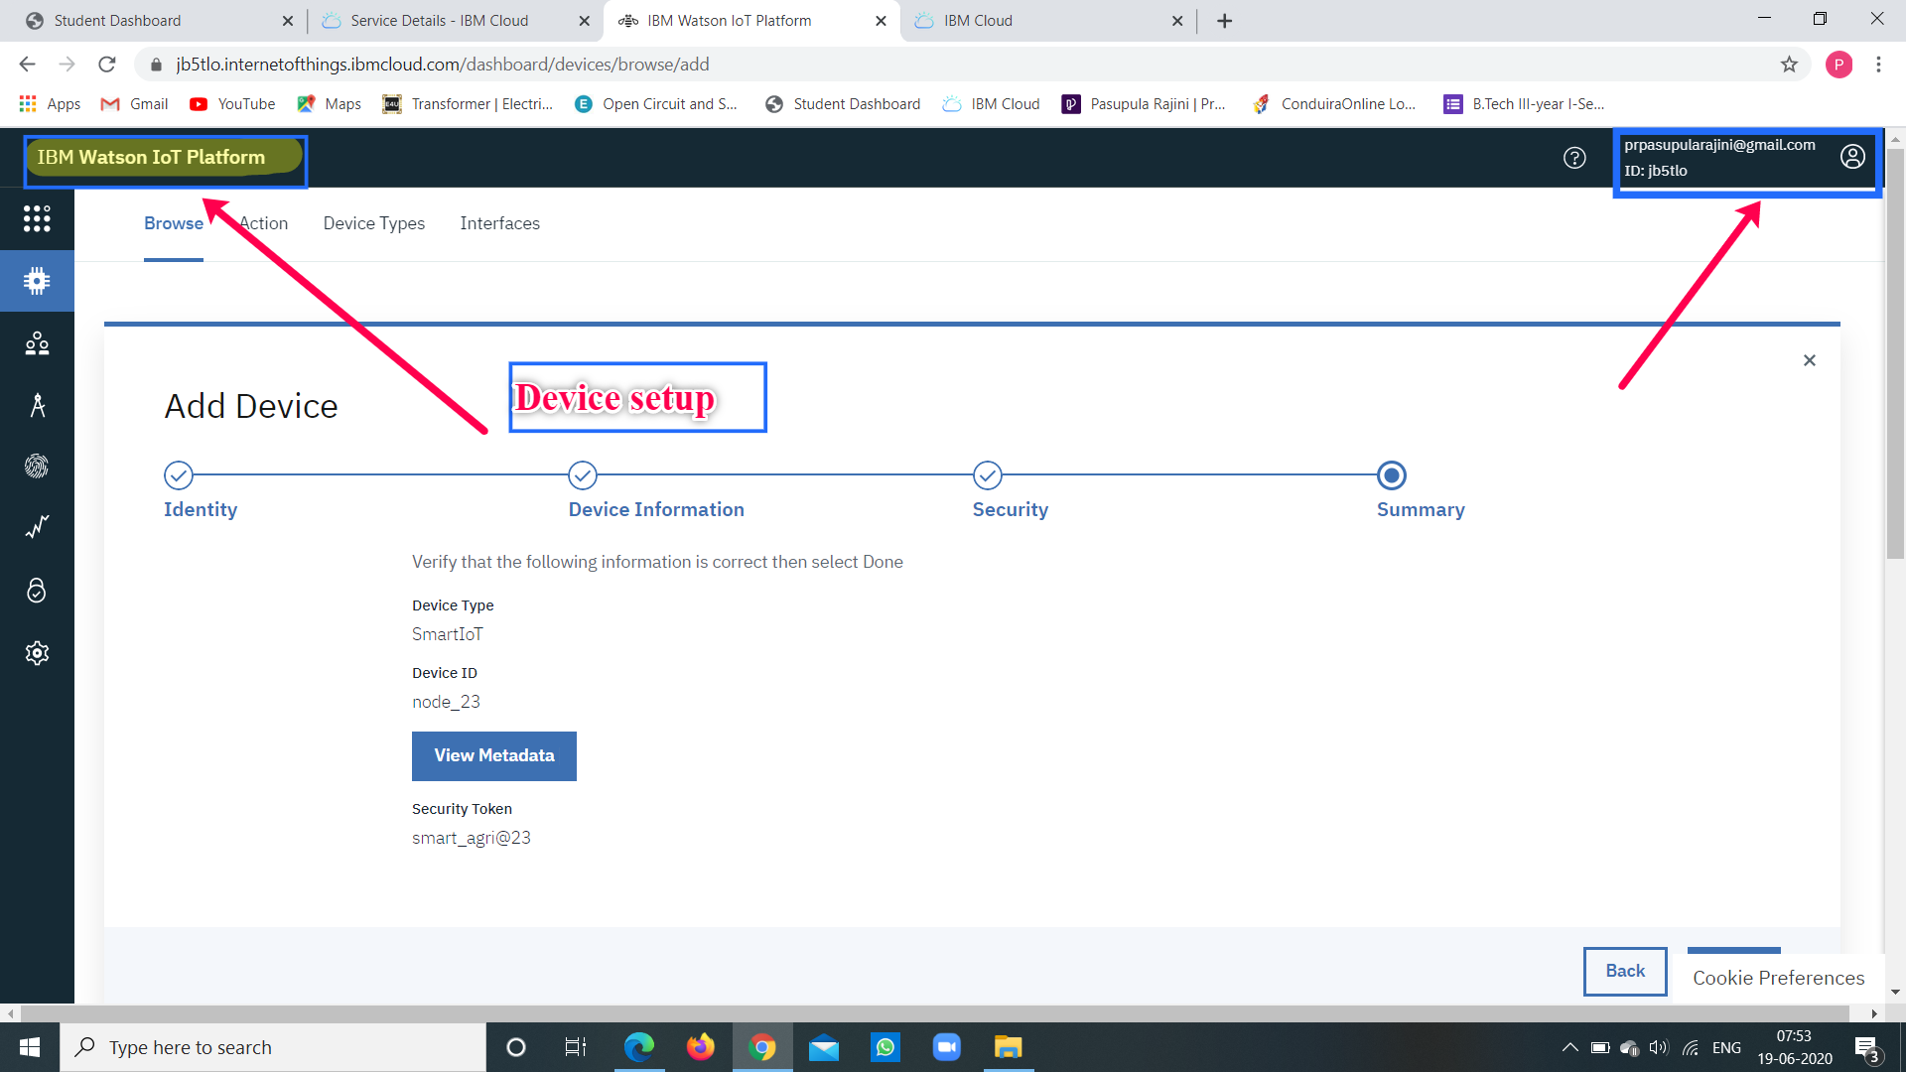

* 20/06 - Development Environment

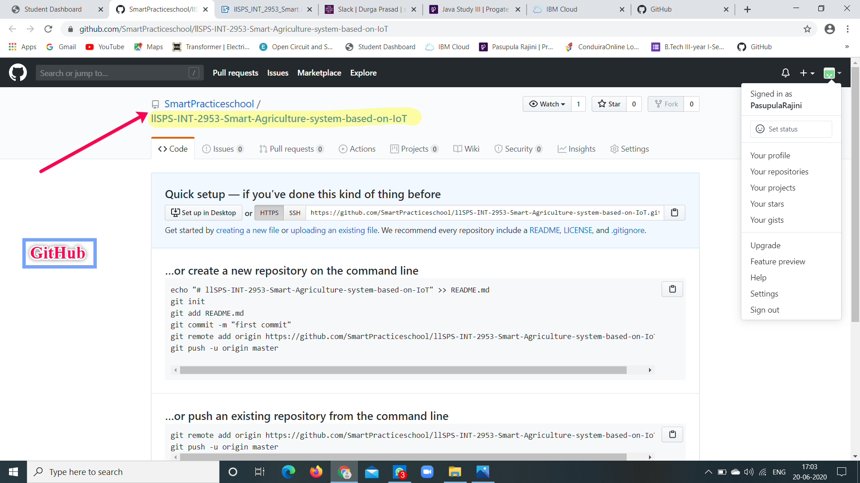

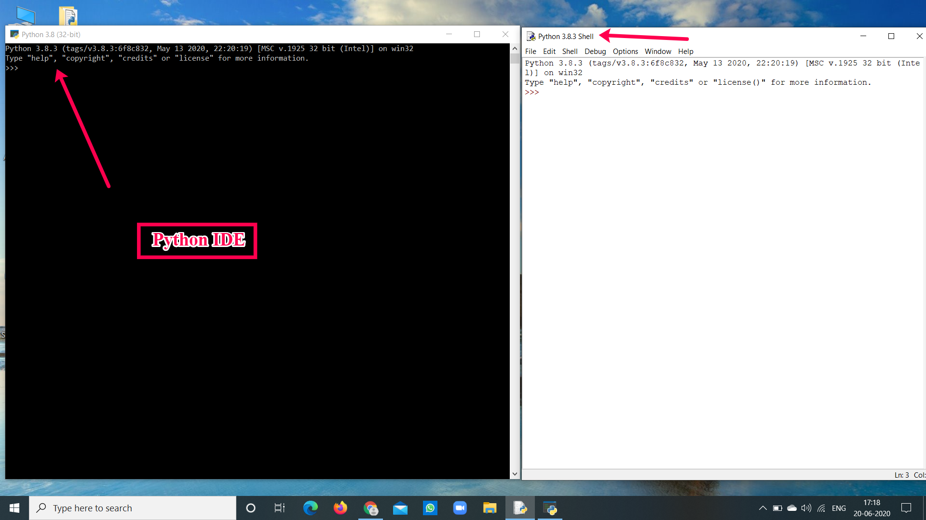

* 22/06 -Connecting the IOT Simulator To Watson IOT Platform.

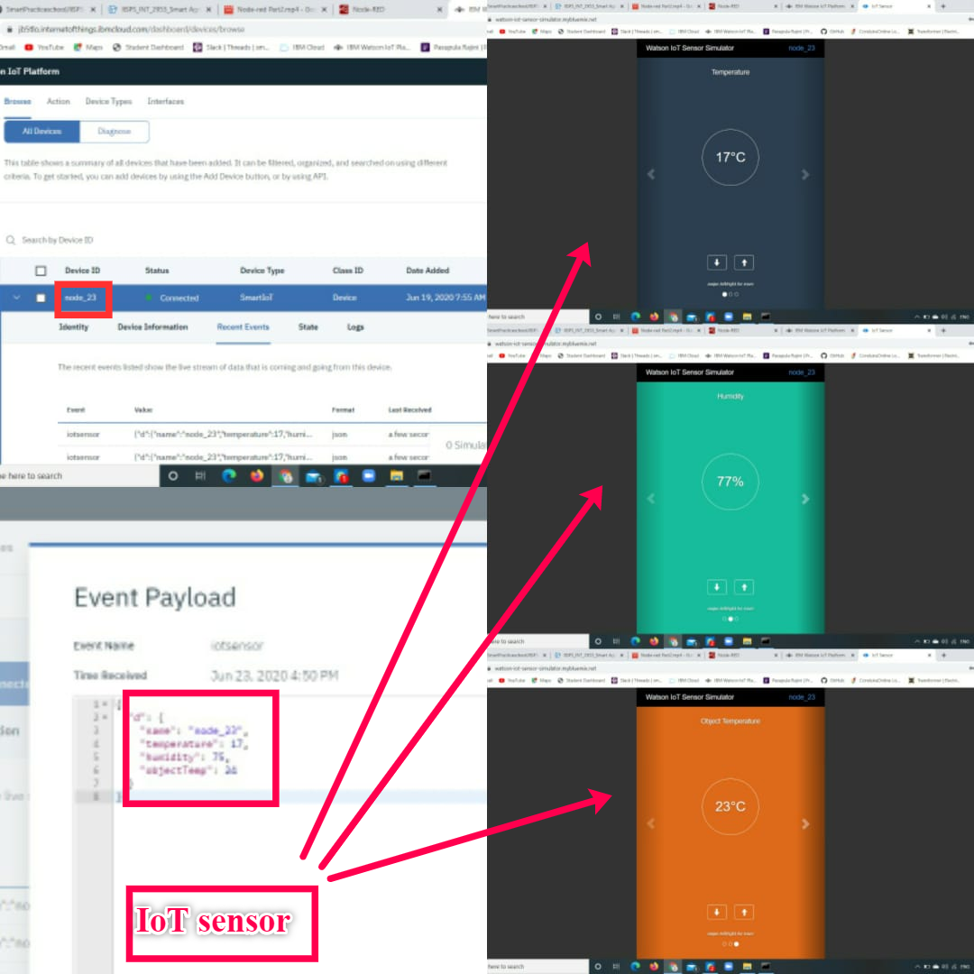

* 23/06 - installing of Node.is & Node-Red

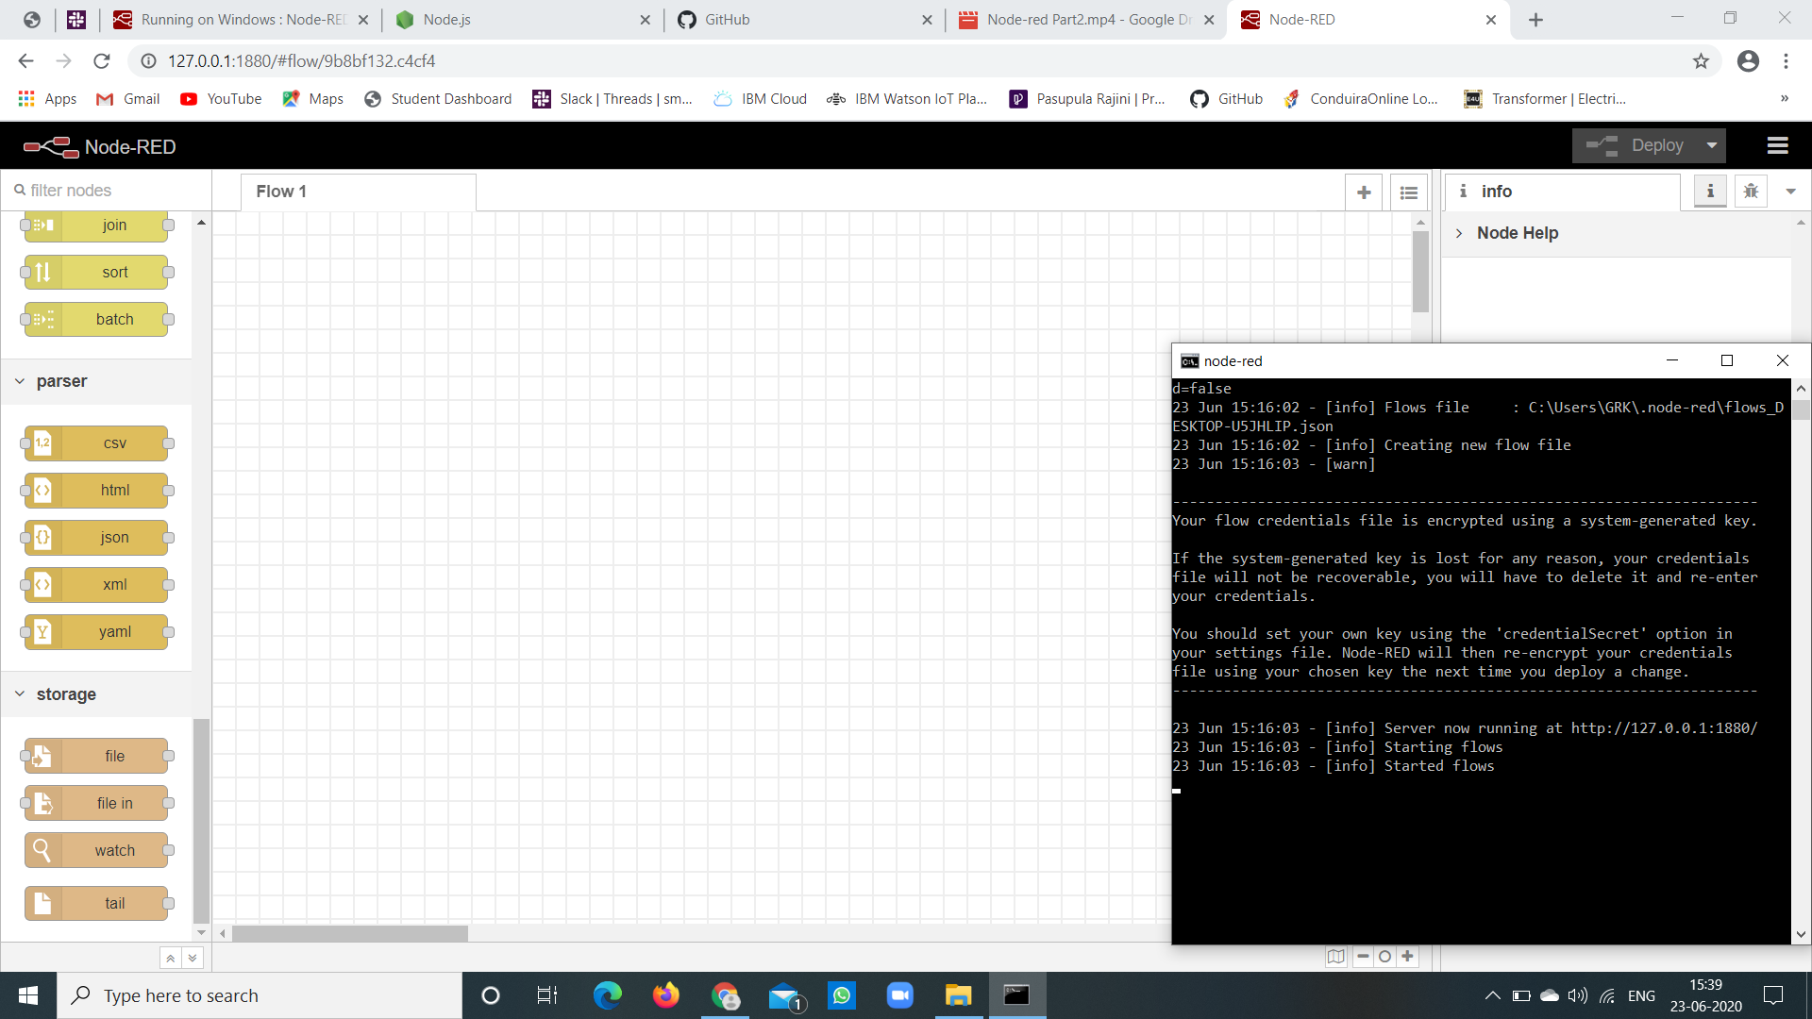

* 24/06 - Installing required nodes and connecting to IBM Watson IoT Sensor

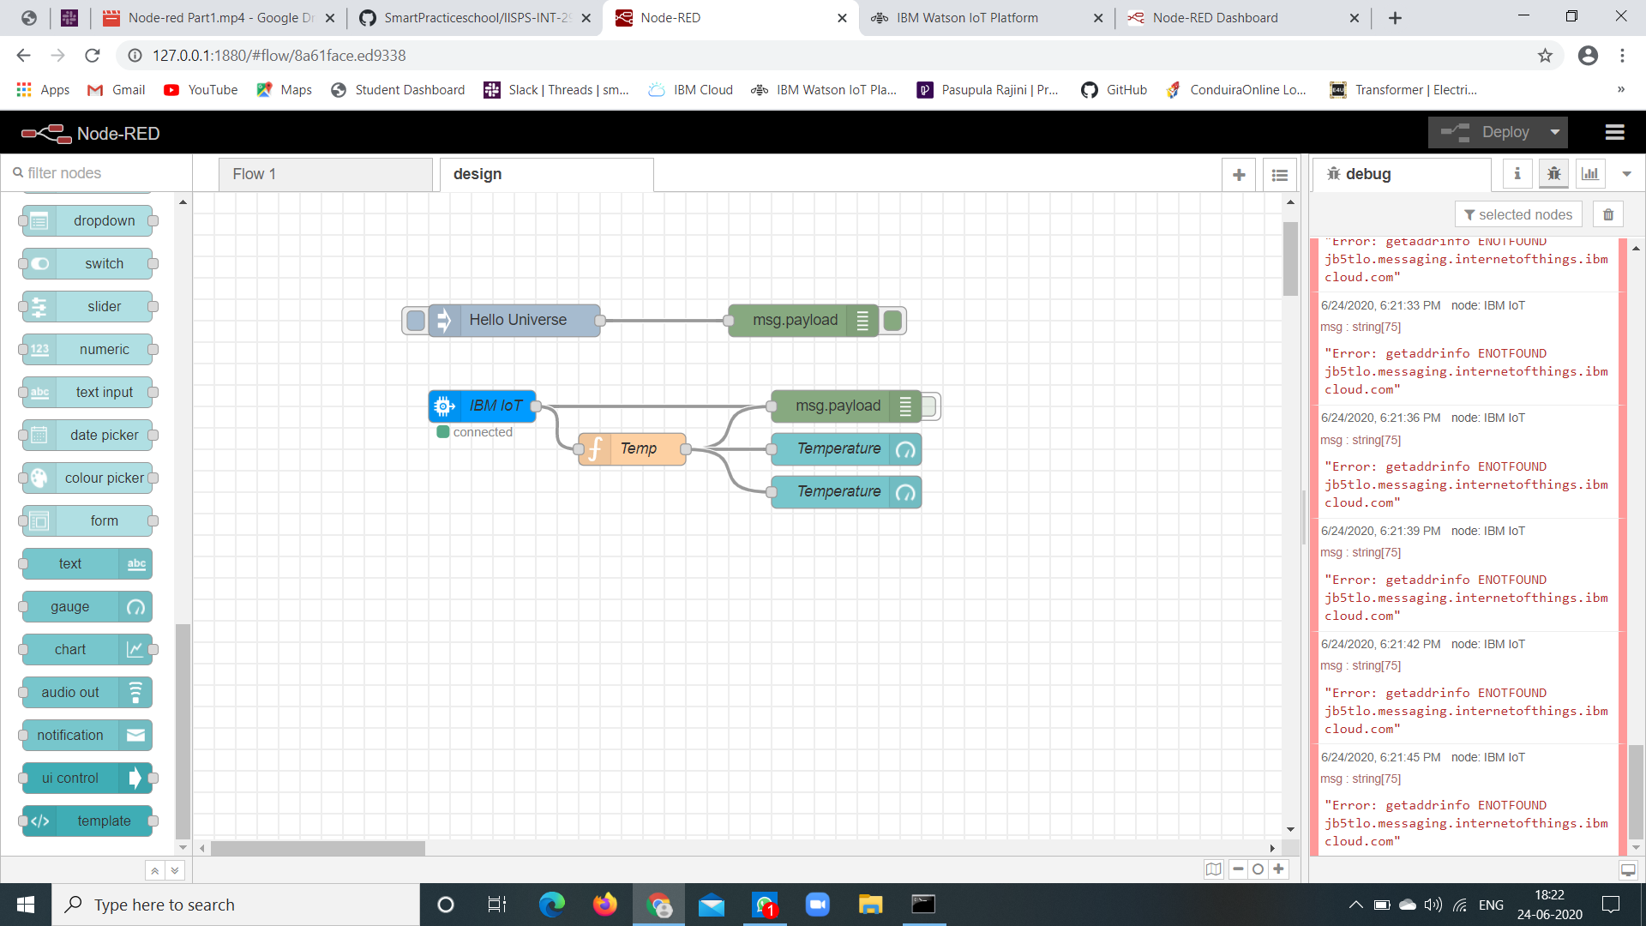

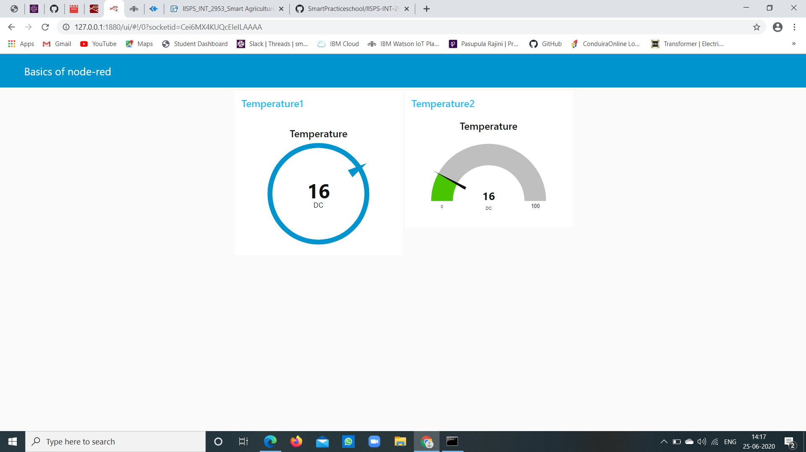

* 25-28/06 - Creating web app and working with python code
* 30/06 -Completion of project

**Project Team:** Project by "**Pasupula Rajini**"- {**Project Manager**}

**Project Deliverables:**

This is a user friendly app .Which would greatly help people working in farming sector .By which user can monitor and complete their required tasks such as turning on/off motor .And also make requisite changes in their working field according to the data provided by this app(i.e. Humidity,temperature,soil_moisture..).

# 

# 

# 

# 

# 